Matthew Gamboa

Module 10.2

12/15/24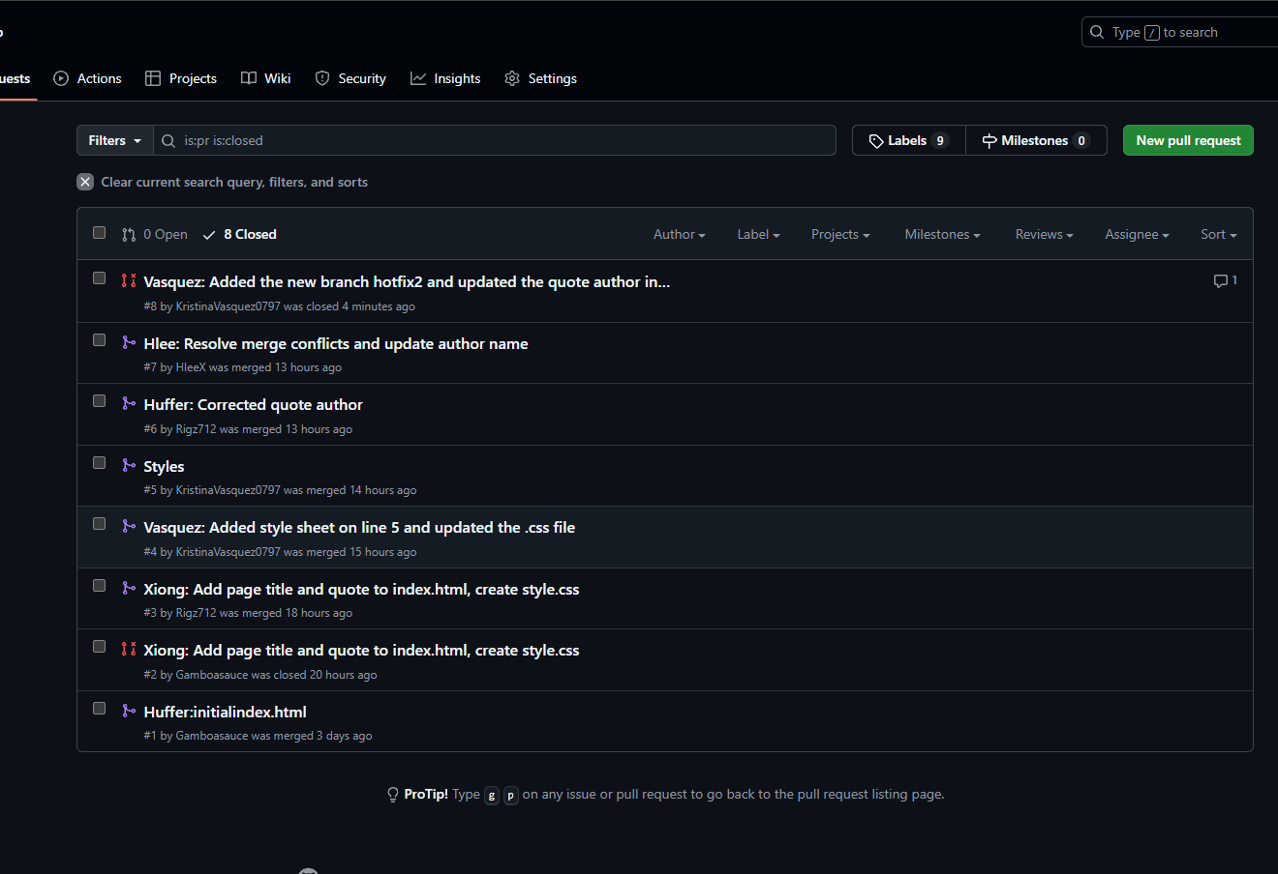

GitLab: <https://github.com/Gamboasauce/GitLab>  
Username: Gamboasauce